Specific learning objectives
- To name and mark the parts of the stomach
- To mark the orifices of the stomach
- To enumerate the arteries supplying the stomach
- To appreciate the nerve supply of stomach
Curvatures of stomach - lesser and greater
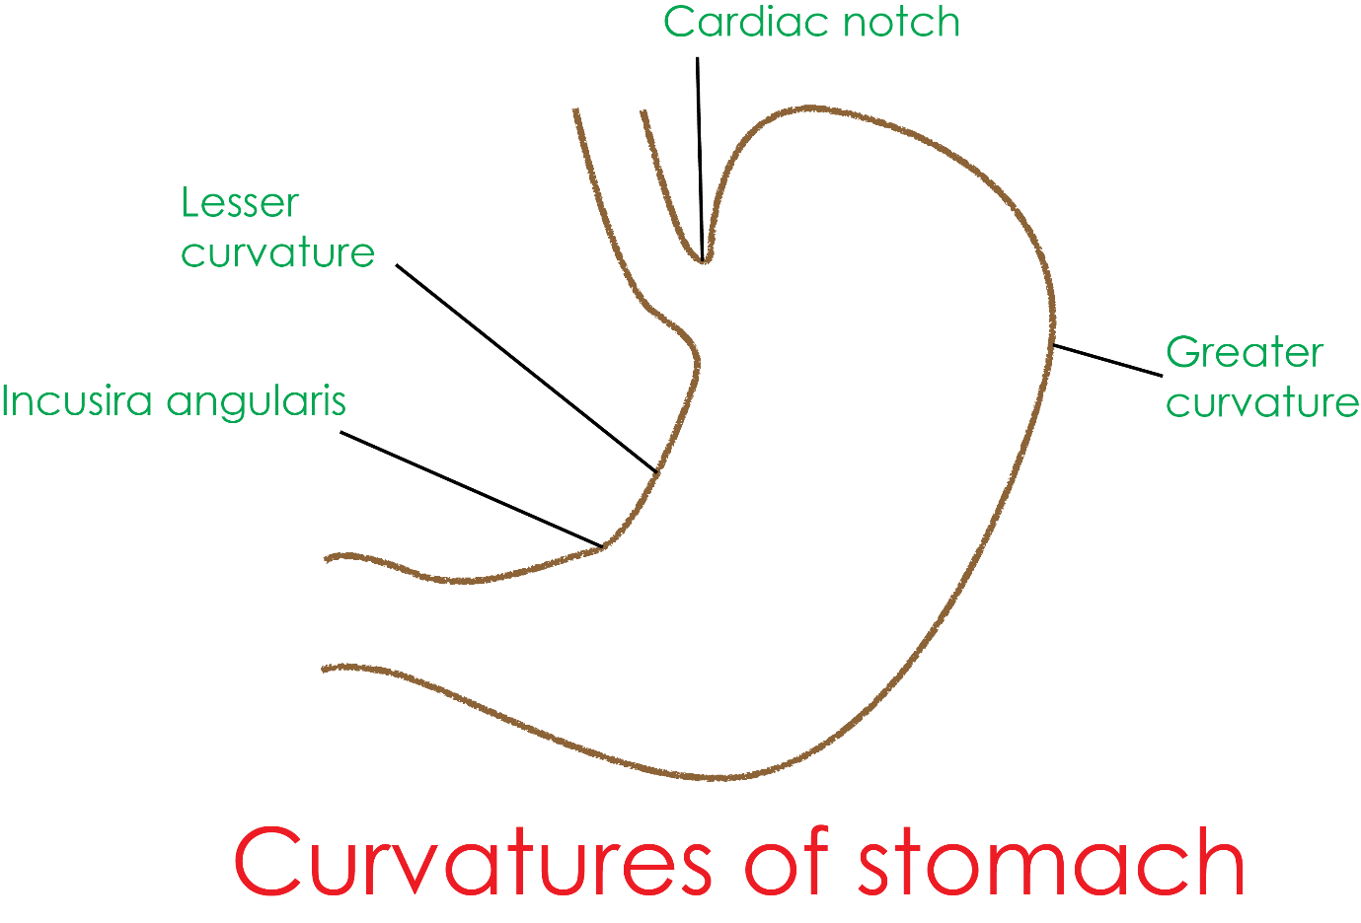
Orifices of stomach - cardiac and pyloric
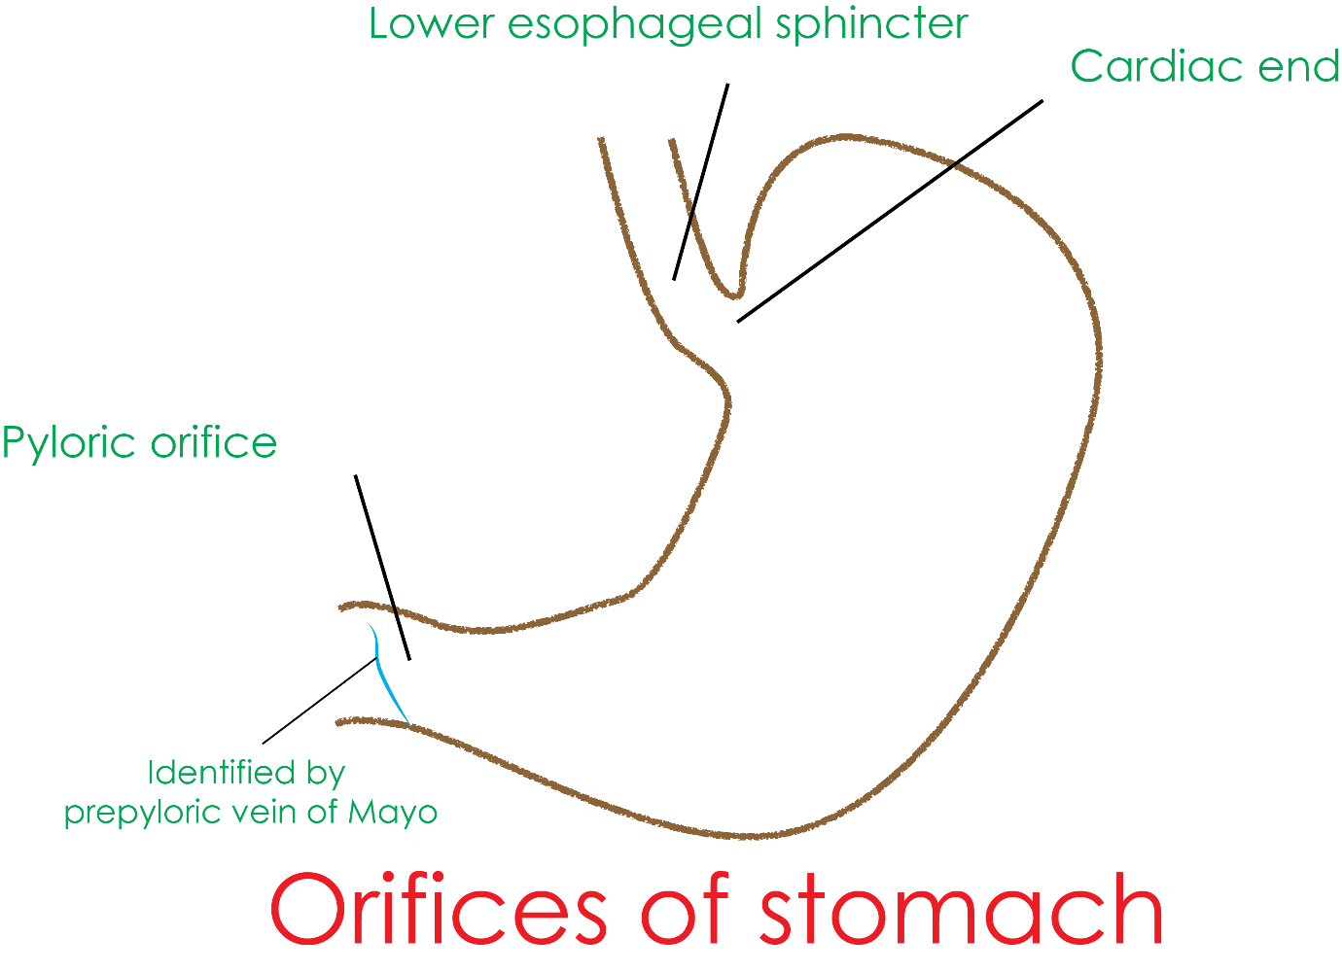
parts of stomach - fundus, body and pylorus
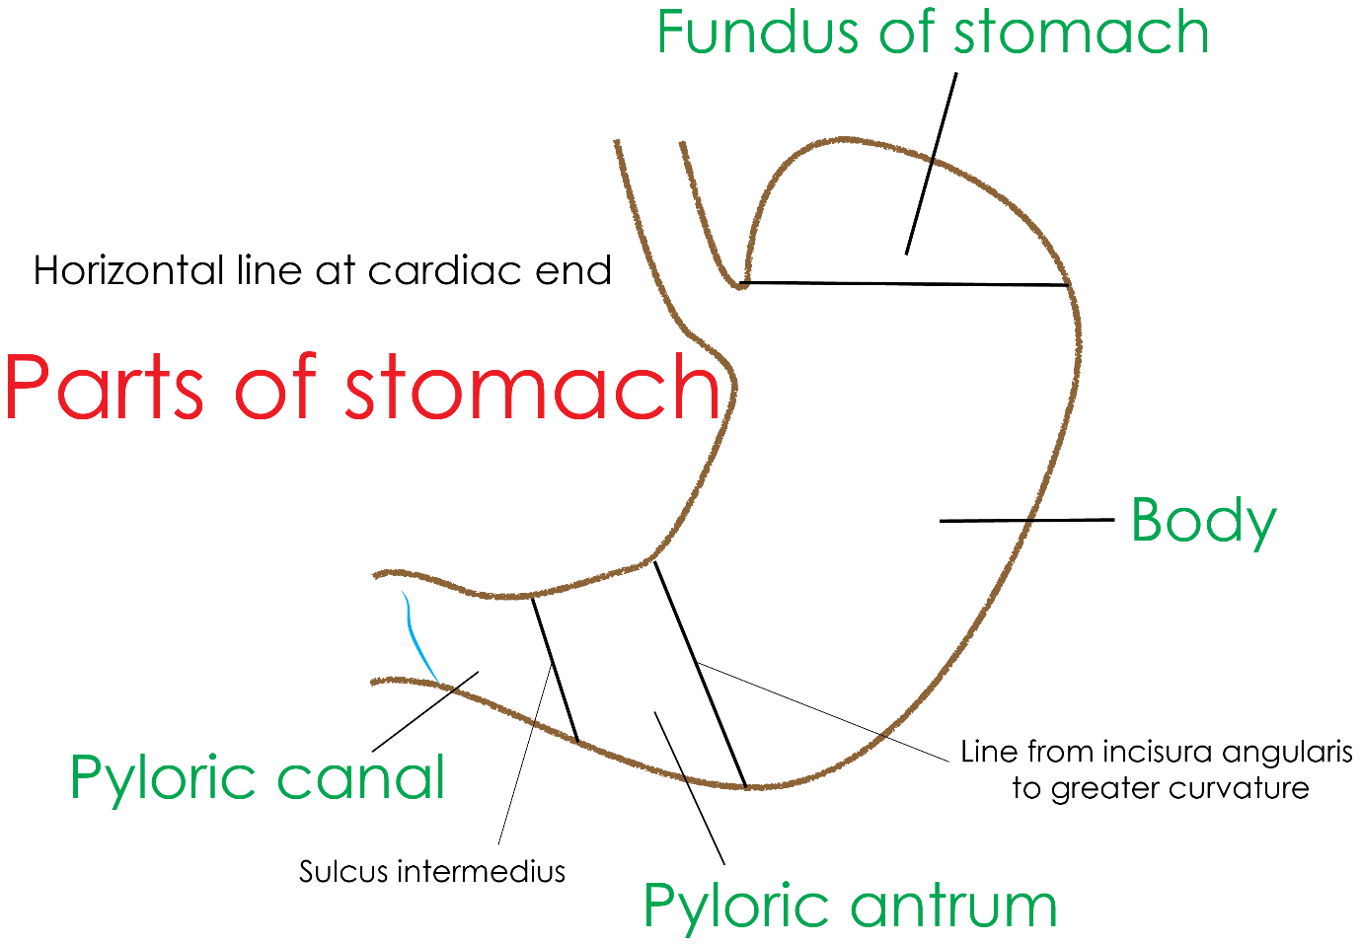
Anterior relations - liver and anterior abdominal wall
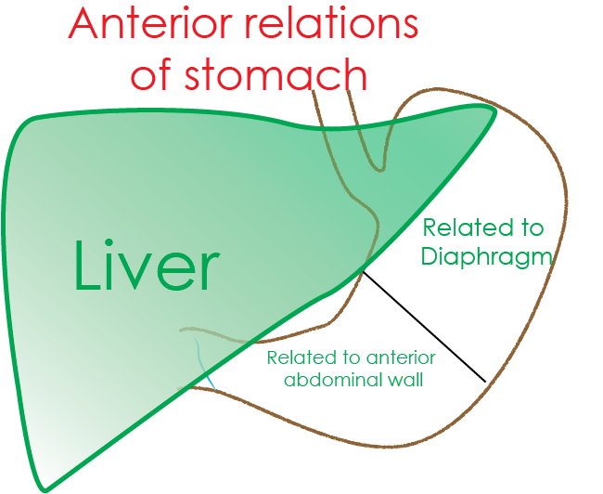
Stomach bed
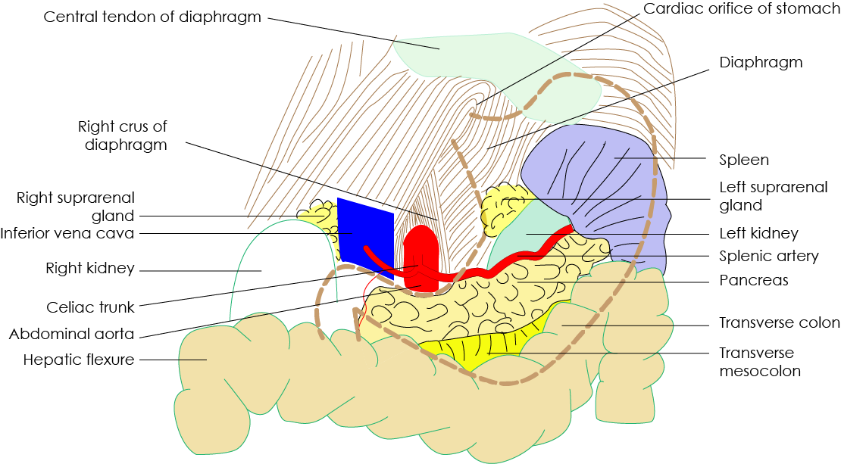
Attachment of lesser omentum
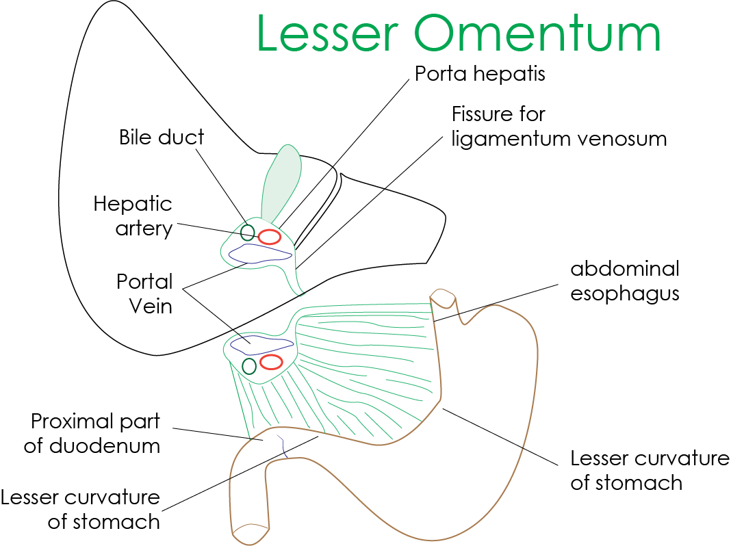

Parietal cells and acid production
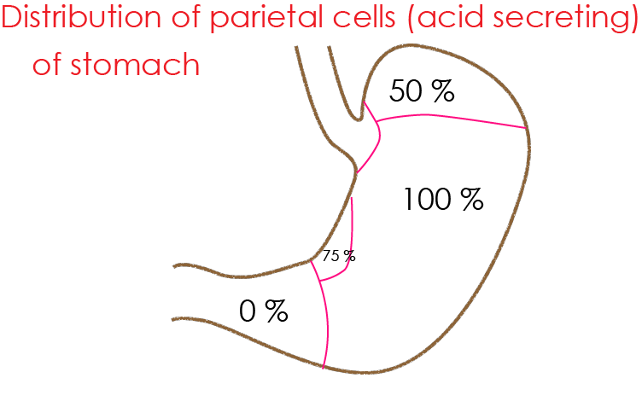
Attachment of greater omentum
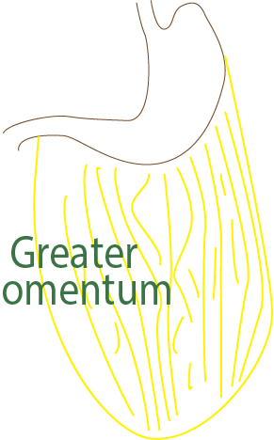
Gastrin production and mucus
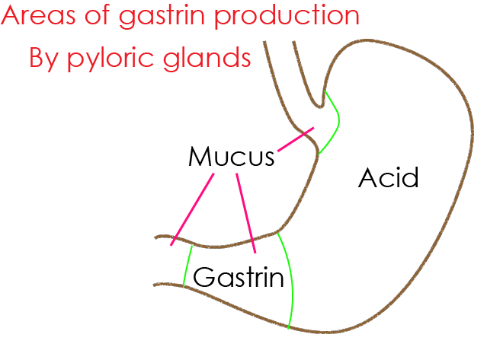
Veins of stomach drain into portal vein
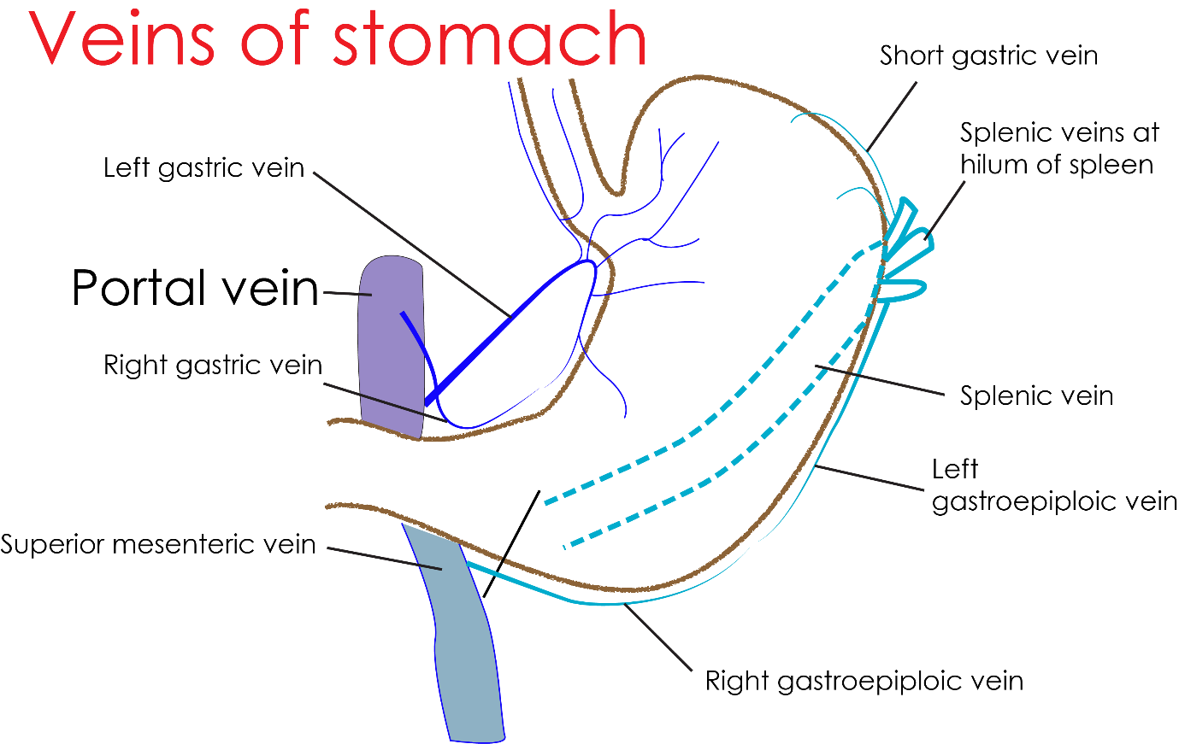
Two vagus nerves - anterior and posterior are secretomotor parasympathetic to stomach

